Essential Maths Test 1 MAWA – Unit 1

Name: ________________

**Percentages and Rates Test**

**Total Marks /40**

**1. (1, 1, 1, 1) (4 marks)**

An exceptional track athlete can run 100 metres in 10 seconds. Convert a speed of 100 metres in 10 seconds to a speed in:

a) metres per second.

b) metres per minute.

c) metres per hour.

d) kilometres per hour

**2. (1, 1, 1) (3 marks)**

What unit of measurement would you use to measure the speed of:

a) an automobile?

b) a swimmer in a 200m race?

c) a jet aeroplane in full flight?

**3. (2, 3, 2) (7 marks)**

Jane is driving to Perth from Karratha, 1 545km away. Her Toyota

Hilux uses diesel at a rate of 8.3L per 100km.

1. How much fuel will Jane use to travel the 1545km trip?

b) If her fuel tank holds 76 L of fuel, how many times will she need to fill up her fuel tank?

c) Diesel fuel prices in northern W.A average 168 c/L. Based on your answer in a) calculate the total cost of petrol for the trip.

**4.** (2, 2, 1, 1, 1, 2, 2, 2, 2) **(15 marks)**

i) Joel earns $83 542 per year.

1. Calculate how much he gets each week. ____________
2. He works 40 hours each week. Find Joel’s hourly rate.

working

___________

ii) Show how you would estimate an approximate answer to the following:

1. 6 x 99

Do not calculate the exact answers.

1. $31.99 + $0.98 + $16.48

iii)

1. Find 13% of $300
2. 31.5% of 5 km giving your answer in metres.

iv) At a roadside fruit stall, avocados cost $0.85 each or you can get 8 avocados for $5

1. If you buy 8 for $5, what is the cost of each avocado? ________
2. If you buy 8 avocados how much will you save

by using the 8 avocado for $5 deal?

________

1. You need at least 22 avocados for a party recipe.

What is the cheapest price you can get them? Show how.

working

_________________________

**5. (1, 2, 2, 1, 2, 1, 2) (11 marks)**

Jack and Carol take their dog for a walk every day. A time distance graph showing their journey one day is shown below.

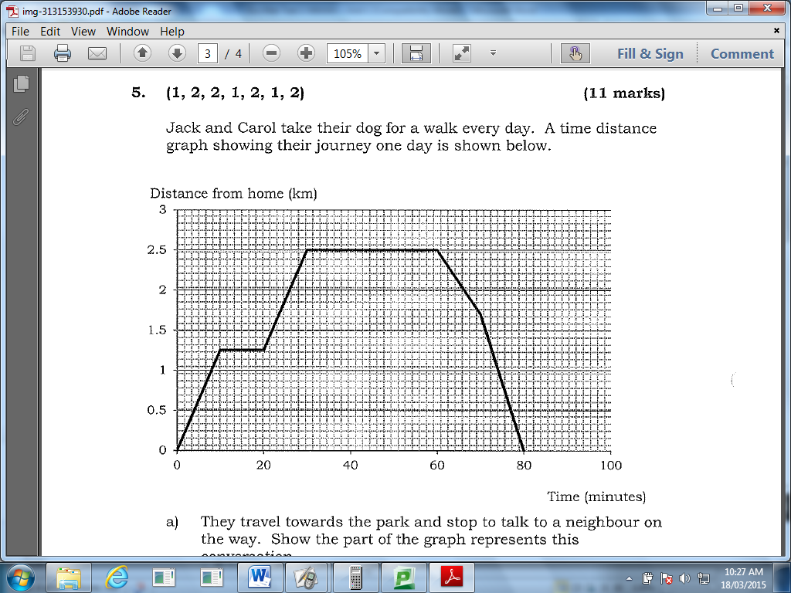

a) They travel towards the park and stop to talk to a neighbour on the way. Show the part of the graph represents this conversation.

b) Calculate the percentage of the whole journey that they spent talking to the neighbour.

c) If they left home at 7:45am, what time did they arrive at the park and how long did they stay there?

d) How far away is the park from their home?

e) Calculate the average speed they walked for the first 30 minutes.

f) Show on the graph the part of the journey when the dog got excited because he saw a cat and so they then walked at a faster pace.

g) Using your answer in f) calculate the speed of the dog when he saw the cat.

Essential Maths Test 1 MAWA – Unit 1 **SOLUTIONS**

**Percentages and Rates Test**

**Total Marks /40**

**1. (1, 1, 1, 1) (4 marks)**

An exceptional track athlete can run 100 metres in 10 seconds. Convert a speed of 100 metres in 10 seconds to a speed in:

a) metres per second. **10m/s ✓**

b) metres per minute. **600m/min ✓**

c) metres per hour. **3600m/hr ✓**

d) kilometres per hour **36km/hr ✓**

**2. (1, 1, 1) (3 marks)**

What unit of measurement would you use to measure the speed of:

a) an automobile? **km/hr ✓**

b) a swimmer in a 200m race? **m/s ✓**

c) a jet aeroplane in full flight? **km/hr ✓**

**3. (2, 3, 2) (7 marks)**

Jane is driving to Perth from Karratha, 1 545km away. Her Toyota

Hilux uses diesel at a rate of 8.3L per 100km.

1. How much fuel will Jane use to travel the 1545km trip?

**~ 128 L✓✓**

b) If her fuel tank holds 76 L of fuel, how many times will she need to fill up her fuel tank?

**~ 1.7 times✓✓ Fill up twice ✓**

c) Diesel fuel prices in northern W.A average 168 c/L. Based on your answer in a) calculate the total cost of petrol for the trip.

**$215.04✓✓** (answers may vary based on answer to a)

**4.** (2, 2, 1, 1, 1, 2, 2, 2, 2) **(15 marks)**

i) Joel earns $83 542 per year.

a) Calculate how much he gets each week. __**$1606.58✓✓**_

b) He works 40 hours each week. Find Joel’s hourly rate.

working

__**$40.16✓✓**_

ii) Show how you would estimate an approximate answer to the following:

a) 6 x 99 **6 x 100 = 600✓**

Do not calculate the exact answers.

b) $31.99 + $0.98 + $16.48 **$32 + $1 + $16 = $49✓**

iii)

a) Find 13% of $300 **$39✓**

b) 31.5% of 5 km giving your answer in metres. 31.5/100x5= **1.575km✓✓**

iv) At a roadside fruit stall, avocados cost $0.85 each or you can get 8 avocados for $5

a) If you buy 8 for $5, what is the cost of each avocado? __**$0.625✓✓**______

b) If you buy 8 avocados how much will you save

by using the 8 avocado for $5 deal?

**0.85 x 8 = $6.80** _**Save $1.80✓✓**_

c) You need at least 22 avocados for a party recipe.

What is the cheapest price you can get them? Show how.

2 x $5 + $0.85 x 6 = $15.10 or 3 x $5 = $15 with 2 extra

working

_____**∴ $15 ✓✓**_____

**5. (1, 2, 2, 1, 2, 1, 2) (11 marks)**

Jack and Carol take their dog for a walk every day. A time distance graph showing their journey one day is shown below.



f)

a)

a) They travel towards the park and stop to talk to a neighbour on the way. Show the part of the graph represents this conversation.

**See graph✓**

b) Calculate the percentage of the whole journey that they spent talking to the neighbour.

**10 ÷ 80 x 100 = 12.5% ✓✓**

c) If they left home at 7:45am, what time did they arrive at the park and how long did they stay there?

**8.15am ✓ stayed 30 min ✓**

d) How far away is the park from their home?

**2.5km ✓**

e) Calculate the average speed they walked for the first 30 minutes.

**5 km/hr ✓✓**

f) Show on the graph the part of the journey when the dog got excited because he saw a cat and so they then walked at a faster pace.

**See graph✓**

g) Using your answer in f) calculate the speed of the dog when he saw the cat.

**1.7 km/10min ✓✓ 10.2 km/hr✓**

**Can vary 1.7-1.8 km/min gives 10.2-10.8 km/hr**